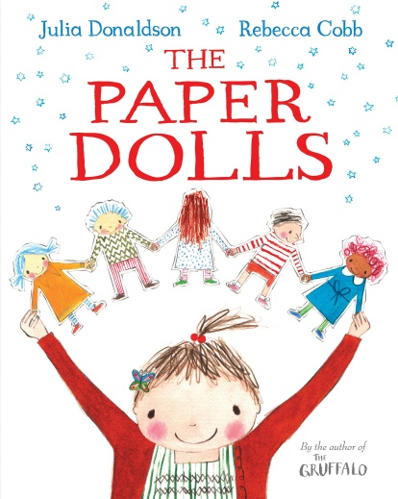  Book Title | Refrains:  As you read through the story encourage your child to join in with the refrains e.g  “You can’t get us. Oh no no no! We are holding hands and we won’t let go. We are ………(Ticky and Tacky) and……. (Jackie the Backie) And Jim with two noses and Jo with….(the bow)!
Describing the pictures:  *When the little girl is sitting on her bed, what can you see?  *How many paper dolls can you see in the story?  *Tell me which is your favourite page and why? | Activities:  *Create a role play scene with a doll’s house and dolls, add a dinosaur and a crocodile so children can re-tell the story in their own way.  *Encourage children to use scissors and support them with making snips in the paper; this will support fine motor skills which are key for writing.  *Involve children and encourage them to create their own paper dolls. Use a range of art materials and resources so they can be creative and use their imagination.
New words:  *slippers  *gnashed  *memory  *bow  *clawed  *crouched  *snarled | Things to talk about:  *Who is helping the girl to make her paper dolls?  *What do you think we need to make our own paper dolls?  *What things are in the little girl’s memory?
Talk about feelings:  *How do you think the girl is feeling when she made her paper dolls with her mummy?  *I wonder how she felt when the boy came up with the scissors and snipped her paper dolls into pieces? | I wonder...  *I wonder why the boy snipped the paper dolls into tiny pieces?  *I wonder what the little girl’s favourite food is?

