15 December 2022 Cambs EYC News Round-Up

Cambridgeshire Early Years and Childcare Service

Wonderful Words in the Early Years
Diana Church, Lead SENCo at ACE Nursery School, Cambridge, shares their thoughts about the ‘Wonderful Words in the Early Years’ training delivered by CambsEYC advisor Lucy Frain.
Lucy Frain introduced their recent training in conjunction with Cambridgeshire County Council SALT specialists. The training came with the stark reminder that communication, language and literacy is the best predictor of later attainment in KS1, not only in literacy but also in maths (Better Communication Research Programme 2011).
The Department of Education (DfE) also tells us ‘early language development and communication skills are recognised as primary indicators of child wellbeing’. (DfE ‘Best Start in Speech, Language and Communication’, page10)
As practitioners, we of course recognise this. We continuously observe, listen, imitate, interpret, model and scaffold play and communication, whilst following the lead of the child. It is these quality interactions that support and enable language acquisition. Repetition is key. A child needs to hear a new word used multiple times, in a variety of ways, before it becomes embedded in their working, long-term memory. This requires a multi-modal approach, including; storytelling and story sacks, songs and rhyme, talking boxes, small world, actions and pictures - all used both indoors and outdoors.
Please note further practical advice and ideas can be found at:
- Integratedtreatmentservices.co.uk
- Concept Cat/Word Rap YouTube video.
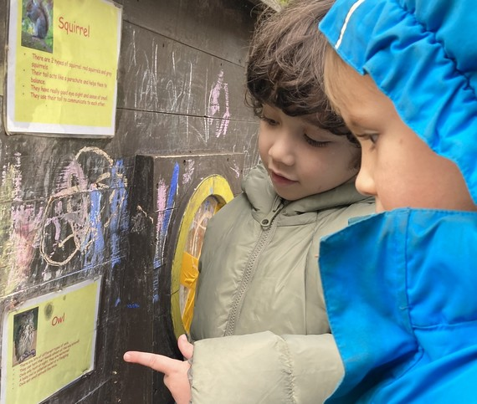
By celebrating wonderful words in our everyday best practice, we can play a hugely significant role in closing the gap which has been made wider by the impact of COVID.

ACE Nursery children reading notices on public display board.

